State Diagrams

Since the Flight Management System is mainly an information processing system, the objects within it do not possess complex states. Working on the Boundary-Controller-Entity framework, most of the classes contain methods which process data and pass the data to another class either for displaying or writing to database. Therefore, we only have two classes that have sufficiently different states and can change states during the execution of the system: SystemAdministratorRole.java and UserController.java.

UserController.java

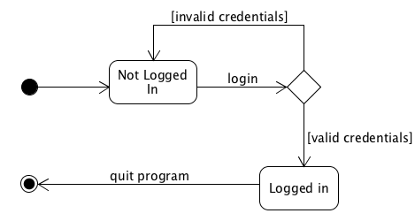

SystemAdministratorRole.java

